**= **

**THE-HUB Hotel Contract Agreement Letter**

Date: 23/01/2019

**Asia Expeditions Co., Ltd (Myanmar)**

**House #04, RM (E), 5th Floor Corner of Anawyahtar Road and Lower Pazundaung.  
Pazundaung ,Yangon, Union of Myanmar  
Tel: +95-1-200 401 / Fax: + 95-1- 397 607**

**HP: +95 -9-5062644 / +95 -9-401533484 /+95-9-254219046  
Email:** [**phyo@asia-expeditions.com**](mailto:phyo@asia-expeditions.com)**,** [**myanmar@asia-expeditions.com**](mailto:myanmar@asia-expeditions.com) **website:** [**http://www.asia-expeditions.com**](http://www.asia-expeditions.com/)

Dear Sir/ Madam,

Warmest greetings from the THE-HUB Hotel, Yangon! We thank you and look forward to your continuous and future support for our Hotel.

For your guest's accommodation requirements kindly refer below the room rates:

**Contract rate Period: 01st  Jan 2019 to 31st Dec 2019**

|  |  |  |  |  |  |
| --- | --- | --- | --- | --- | --- |
| **Sr** | **Room Category** | **Green Season**  **( May’19 - Sept’19 )** | | **High Season**  **( Jan’19 to April’19 )**  **&**  **( Oct’19 – Dec’19 )** | |
| **Local** | **FR** | **Local** | **FR** |
| **1** | **Junior Suite ( 7 )** | **80,000** | **$ 80** | **85,000** | **$ 85** |
| **2** | **Family Room ( 7 )** | **80,000** | **$ 80** | **85,000** | **$ 85** |
| **3** | **Deluxe Room ( 7 )** | **55,000** | **$ 55** | **60,000** | **$ 60** |
| **4** | **Superior Room ( 28 )** | **40,000** | **$ 35** | **45,000** | **$ 40** |
| **Extra Bed** | | **Ks -20,000 & $ 20** | | **Ks -25,000 & $ 25** | |

The above rates are quotes in US Dollar.

All above rates are inclusive of breakfast

All above rate are Nett, inclusive of prevailing government tax and service charge.

***Terms and Conditions***

***Child Policy***

The Hotel will provide complimentary breakfast for children under 6 years of age occupying the same room with parents.

***Check-in/ Check-out***

Normal check-in time is 14.00 hours (2.00 pm) and check-out time is 12.00 noon (12.00 pm). All check-ins and late check-outs should be advised at the time of reservation made. Any check-out after 20.00 hours (8.00 pm} will be subjected to one night's room charge.

***Early Departure***

The Hotel reserves the right to charge a full day's rate if check-out is earlier than the confirmed date. However, depending on the situation, the Management may exercise discretion on a case to case basis.

***Day Use Policy***

Any request for Day Use will be charged at 70% of the contracted rate subject to room availability.

***Cancellation Policy***

No charge before 14 days prior to arrival.

50% of full payment if less than 14 days prior to arrival.

100% of full payment if less than 7 days prior to arrival.

***Deposit Policy***

At the time of booking, the Hotel reserves the right to request from the Company or the Agent payment amounting to 50% of the total confirmed amount.

***Reservations***

Kindly take note that all new reservations and cancellations through the telephone must be followed up either by fax or e-mail. Reservations to be directed to our Reservation Department at [reception@thehubhotelygn.com](mailto:reception@thehubhotelygn.com) & Sales email : [sales@thehubhotelygn.com](mailto:sales@thehubhotelygn.com) .

***Payment Method***

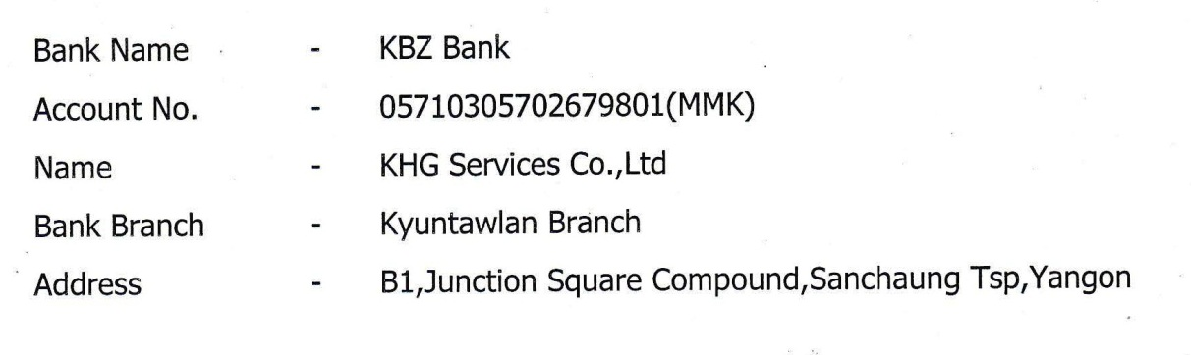

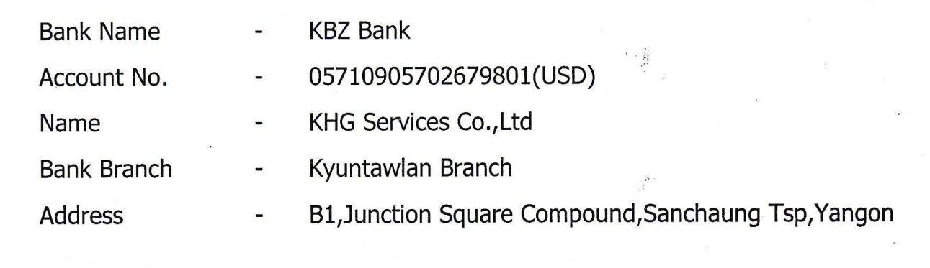

We are pleased to enclose our Contract for your kind perusal. Please sign and return one copy to us.

Thank you for your interest in the THE-HUB Hotel. We look forward to your valuable and kind support.

Please feel free to let us know should your require any further information or assistance.

**On behalf of THE –HUB Hotel On behalf of- Asia Expeditions Co., Ltd (Myanmar)**

------------------------------- -------------------------------

**Ni Ni ( Ms ) Ma Marlar Aye**

**Sales & Marketing Manager Country Manager**

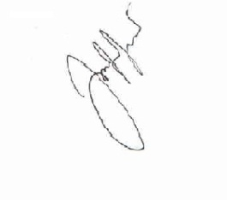

-----------------------

**Thet Ko Ko Tin (Mr)**

**General Manager Of THE HUB-Hotel**